Notre Dame College, a Catholic institution in the tradition of the Sisters of Notre Dame, educates a diverse population in the liberal arts for personal, professional and global responsibility.

NOTRE DAME COLLEGE JOB OPPORTUNITY

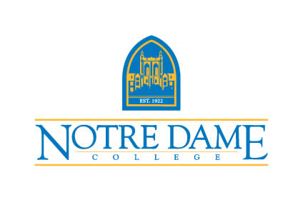
TITLE: Assistant Athletic Trainer
DEPARTMENT: Athletics
REPORTS TO: Student Workers & Work Study Students
POSITION DURATION: 12 Months
JOB STATUS: Full-Time (10-month position – August thru May)
DEADLINE TO APPLY: Posted Until Filled

Job Summary

The Assistant Athletic Trainer is responsible for managing the overall medical care of student athletes orthopedic, medical and mental health conditions related to athletic participation, performing initial injury evaluations, constructing, implementing and managing rehab protocols, and making necessary medical referrals. The Assistant Athletic Trainer will also be required to stay current on all continuing education, NCAA, and conference policies.
Job Duties and Responsibilities:
- Collaboration with sports medicine staff and administration
- Oversee the day-to-day function of the athletic training room.
- Attendance at selected practices and games.
- Record-keeping (including secondary insurance).
- Provide injury prevention, treatment, and rehabilitation for student-athletes.
- Keep an open line of communication with coaching staff and the strength and conditioning coaches in regards to student-athletes currently/recovering from rehabilitation and treatments of injuries.
- Maintain scheduled office hours as well as be present at practices and competitions of assigned sports.
- Knowledge of athletic injury prevention and treatment techniques.
- Uphold the values expected of a Notre Dame College employee as outlined in the NDC employee handbook.
- Assist in Department of Athletics fundraising events as needed.
- Abide by all compliance and regulatory expectations of the department, including but not limited to:
  - Notre Dame College Athletics compliance.
  - NCAA Division II bylaws, rules, regulations, policies, and procedures.
  - Title IX.
  - CLERY Act Regulations.
- Ensure that the program adheres to the rules and regulations of the Mountain East Conference.

Minimum Eligibility Requirements:
Knowledge, Skills & Abilities
Education:
- Bachelor’s degree required. Master’s degree preferred.
- BOC certification.
- State of Ohio License in Athletic Training current or eligible.
- American Red Cross or American Heart Association, CPR and AED training are required.

Experience:
- 1 to 3 years of experience in collegiate athletics preferred.
Environmental Conditions:

- Frequent evening and weekend hours.
- Some travel for practices, and competition.
- Physically active sporting environment requiring the ability to participate in all facets of training and competition of college athletic teams and to lift, move, push equipment and furniture.

How to Apply: The position is open until filled. Submit a letter of application, curriculum vitae, statement of teaching philosophy, and evidence of effectiveness of previous teaching (i.e., student course evaluations) and have three letters of recommendation sent to careers@ndc.edu. Candidates will be interviewed by appointment through Zoom, Microsoft Teams, or at the South Euclid, Ohio campus.

Nestled in the eastern suburbs of Cleveland, our small, Co-ed College features small class sizes and a comfortable atmosphere in a community of learners. Home to some of the country’s best restaurants, medical facilities, museums, sports teams, and amusement parks, Cleveland is an affordable city with major appeal.

