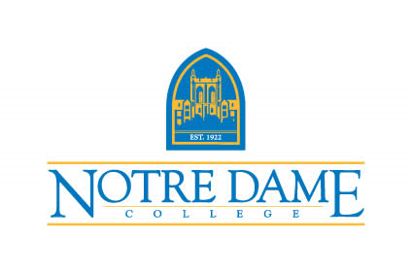
NOTRE DAME COLLEGE
JOB OPPORTUNITY
Notre Dame College, a Catholic institution in the tradition of the Sisters of Notre Dame, educates a diverse population for personal, professional, and global responsibility.
Title: Adjunct Faculty
Department: Biology
Status: Adjunct
Classification: Faculty
Deadline to Apply: Friday, December 17, 2021
Start Date: Monday, January 10, 2021

NDC is looking for adjunct faculty in the Department of Biology to teach the following course :
- BI211 Medical Terminology. The course meets on Wednesday evenings from 7:00-9:30 pm.
Responsibilities:
Prepare and deliver engaging on campus lessons to students. Develop and moderate classroom forums to foster critical and creative thinking. Maintain high academic standards for on- campus environment. Grade and evaluate students' academic work within the time frame set forth by NDC policy. Offer systematic feedback to guide student learning and success. Comply with College, Divisional and Department guidelines and expectations. Respond to students in a timely manner and reply to communication from students within 24 hours Monday – Friday/minimum. Attend discipline specific and administrative meetings for adjunct faculty. Participate in professional development to enhance teaching skills and maintain subject-matter expertise.
Requirements: Academic qualification: M.S. or Ph.D. in Biology (or related field), with a minimum of 18 graduate credits related to the course being taught.
Nestled on 48 scenic, wooded acres in a suburb just 25 minutes from Cleveland, Notre Dame College offers a blend of quiet campus life and big city adventure. Home to some of the country’s best restaurants, medical facilities, museums, sports teams, and amusement parks, Cleveland is an affordable city with major appeal.

How to apply: Please send a resume or curriculum vitae, cover letter and three professional references to: careers@ndc.edu. Candidates will be interviewed by appointment through Zoom, Microsoft Teams, or at the South Euclid, Ohio campus. Only candidates who meet all the specified criteria will be invited to interview.

