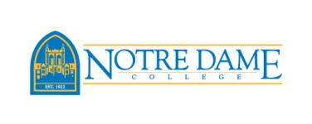

Notre Dame College, a co-educational Catholic institution in the tradition of the Sisters of Notre Dame, educates a diverse population in the liberal arts for personal, professional and global responsibility. Founded in 1922 as a Catholic, four-year liberal arts institution, the College sits on 48 picturesque wooded acres, tucked away in South Euclid, a quiet suburban neighborhood just 25 minutes from downtown Cleveland, Ohio. During the past ten years the College has experienced a period of sustained growth, creativity and renewal. Today Notre Dame College boasts an enrollment of almost 2,200 students. The College offers associate's, bachelor's and master's degrees in over 30 disciplines as well as 22 scholarship athletic sports.

The position: Notre Dame College seeks a dynamic leader for the position of Dean of Student Affairs. Reporting to the President of NDC the Dean is responsible for developing student life on campus, including the overall administration, supervision, and evaluation of student affairs programs and activities including: Residence Life, Counseling Center, Student Engagement, TRIO Grant, FIrstGen, Student Conduct, Falcon Café, Campus Ministry. The Dean supervises and oversees approximately 25 full and part time staff.

Degree requirements: an earned doctorate is preferred; an earned master’s degree in higher education, student personnel administration, or related field is expected.

Experience: The Dean should have 3-5 years of higher education experience preferably in student affairs; prior supervisory experience, and prior experience working directly with college students.

Candidates should have the desire to work in a small, private, Catholic, enrollment-driven, liberal arts-based institution. They should have the ability to function well under pressure and have the ability to manage complex tasks and student issues through direct leadership, delegation to key staff, and collaboration with others.

Interested candidates should submit CV and cover letter with the names and contact information of five professional references to: careers@ndc.edu

