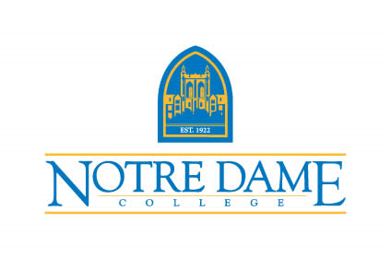
Assistant Director of Residence Life posting

MISSION:
Notre Dame College, a Catholic institution in the tradition of the Sisters of Notre Dame, educates a diverse population in the liberal arts for personal, professional and global responsibility.

Position Title: Assistant Director of Residence Life
Department: Residence Life
Position Duration: 12 months
Hours of Work: 35 hours/week plus on-call; evening and weekend work required

FUNCTION:
The Assistant Director of Residence Life, along with other Residence Life staff, is responsible supporting for five residence halls housing approximately 650 residents. This position is also responsible for supporting a comprehensive student development program consistent with the mission and goals of the College and Department of Student Affairs

This individual must appreciate and support the liberal arts philosophy and education.

QUALIFICATIONS:
A successful candidate will have earned a Master’s Degree in College Student Personnel, Higher Education Administration, Counseling, or related area; have 2+ years of progressive responsibility in Residence Life, Housing, or related area; have program planning experience; have served on-call for crisis management; and have supervision experience.

Outstanding organizational, leadership, management, supervisory, crisis response, programming, interpersonal communication, oral communication, written communication, advising, and problem-solving skills; high degree of energy; sensitivity to the academic and personal needs of college students; understanding of a liberal arts education; and enthusiasm for teaching and learning that goes beyond the classroom.

PHYSICAL ENVIRONMENT:
Office duties conducted within a professional office setting with the need to access campus buildings with stairs and complete campus errands. Regular computer keyboard use. Some light to medium lifting (15-20 lbs.) may be required.

